**Editing Outlook Signature Instructions**

1.***Edit your information in the signature below***. Then, highlight the entire signature and right click, copy.

**First Name Last Name | Title | Trace Staffing Solutions**

1234 Rainbow Lane | City, State Zip

Office: xxx.xxx.xxxx | Cell: xxx.xxx.xxxx

2. Open a New Email.

3. Inside the new email, click the “Signature” drop down arrow at the top. Then, click “Signatures…”

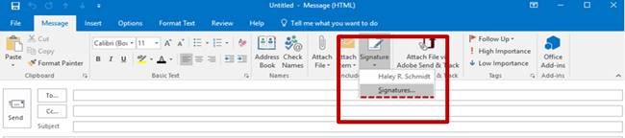

4. This will open a second panel with your signatures. Highlight and delete your current signature.

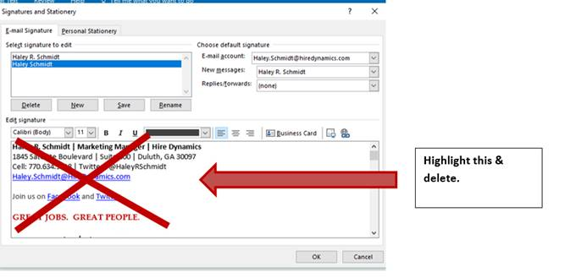

5. Paste your new, edited signature.

6. Click “OK” to save.

7. Return to your new email. To confirm updated signature, click the Signature dropdown box and select the updated version.